HIGH-LEVEL-DESIGN (HLD)
Diagram 1 — System architecture: all major layers and how they connect.
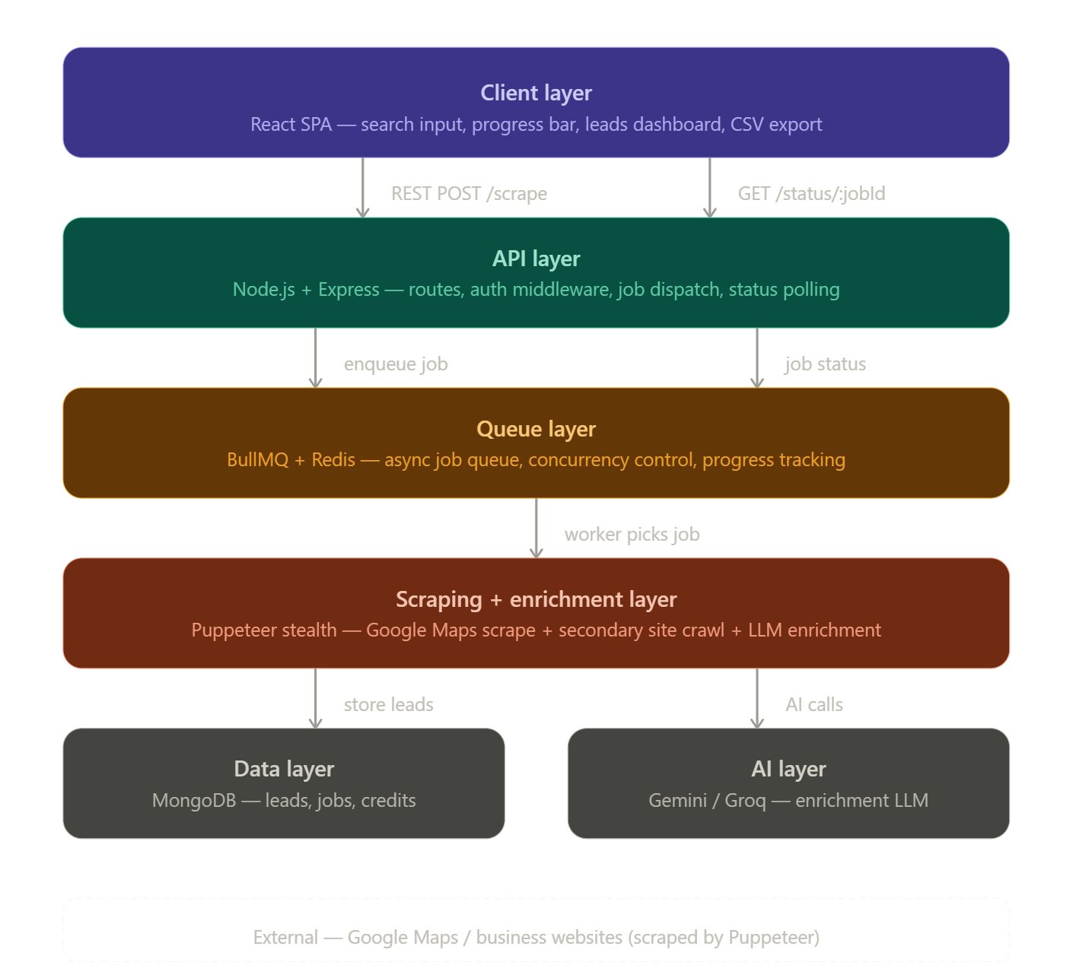

Diagram 2 — Internal data flow: what happens inside the scraping + enrichment layer in detail.

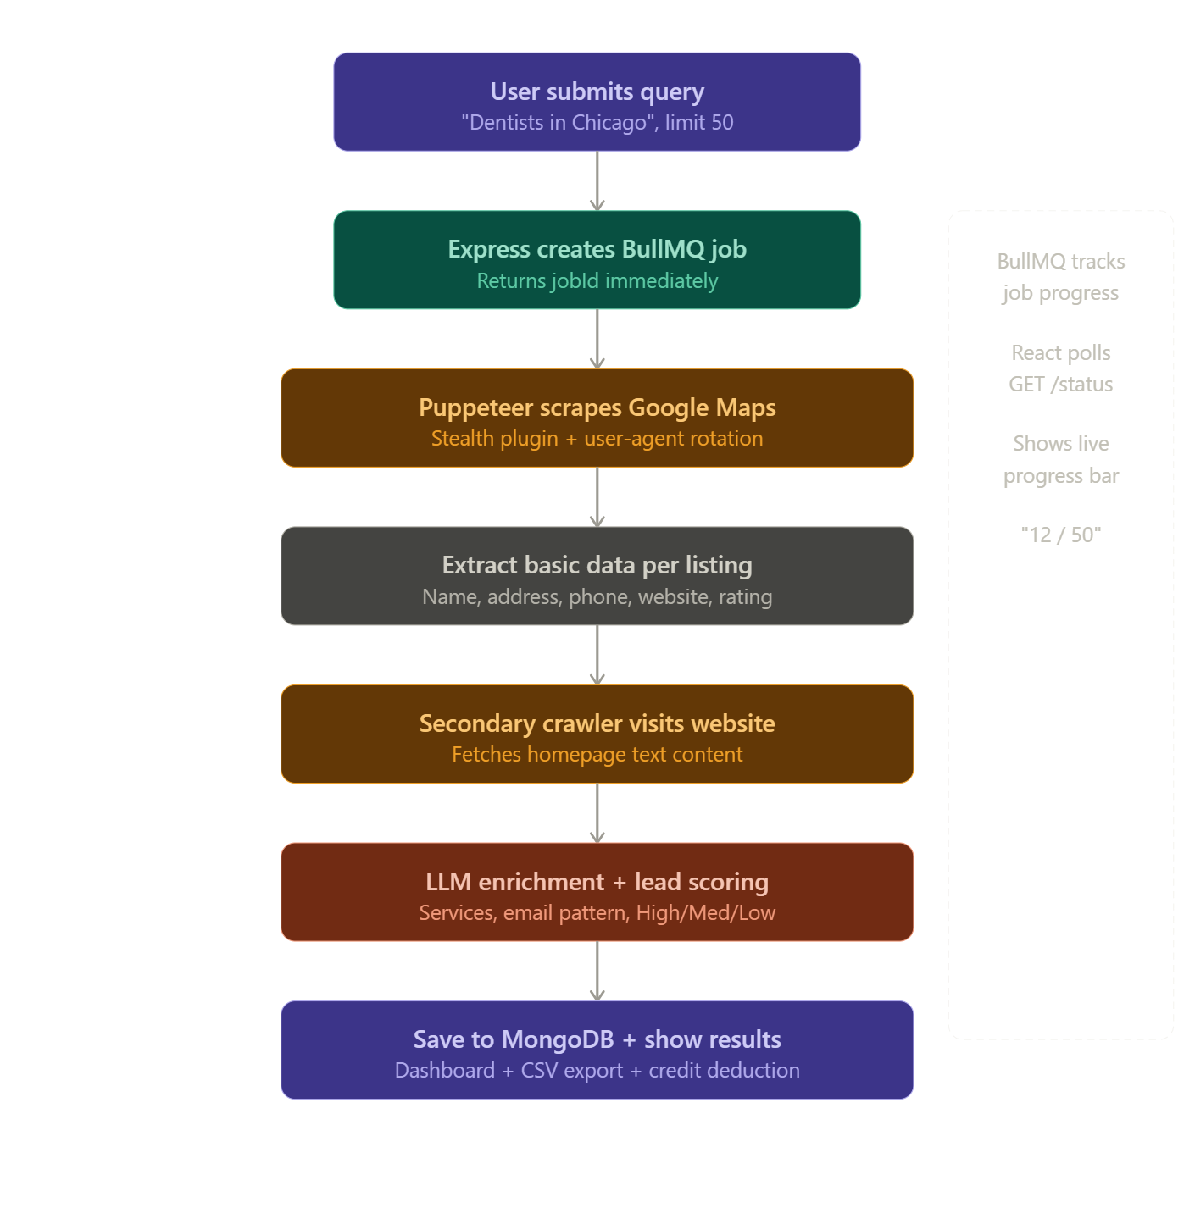

5 distinct layers in the system:
- Client layer — React handles the UI: search input, live progress bar, leads table, and CSV export
- API layer — Express receives requests, dispatches jobs, and serves job status back to the frontend
- Queue layer — BullMQ + Redis decouples the heavy scraping from the web server so the server stays fast and responsive
- Scraping + enrichment layer — the core engine: Puppeteer for Maps scraping, a secondary crawler for each website, and an LLM call for enrichment and scoring
- Data + AI layer — MongoDB stores everything (leads, jobs, credit balance), and Gemini/Groq handles the AI enrichment calls

LOW-LEVEL-DESIGN (LLD)
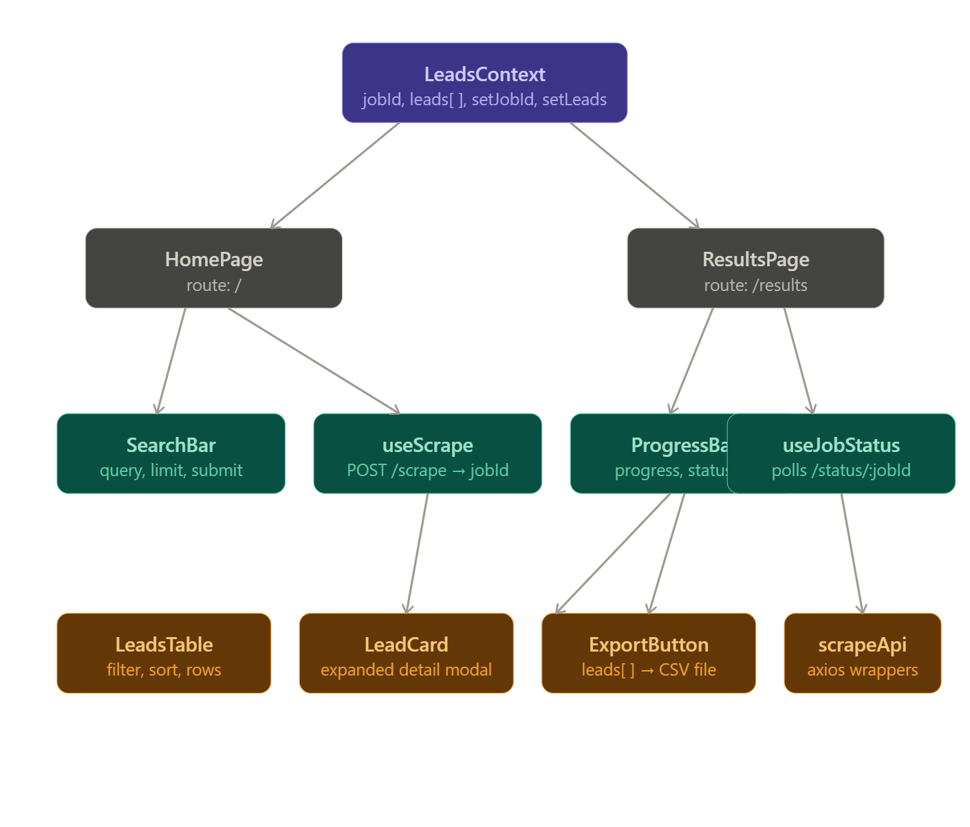
Layer 1 — Client Layer

Client Layer — Key LLD Decisions:
LeadsContext is the backbone — jobId flows from useScrape into it, and leads[] flows from useJobStatus into it. Both pages read from the same context so there's zero prop drilling. scrapeApi.js is the only file that knows the backend URL exists — no component ever calls axios directly.

Layer 2 — API Layer

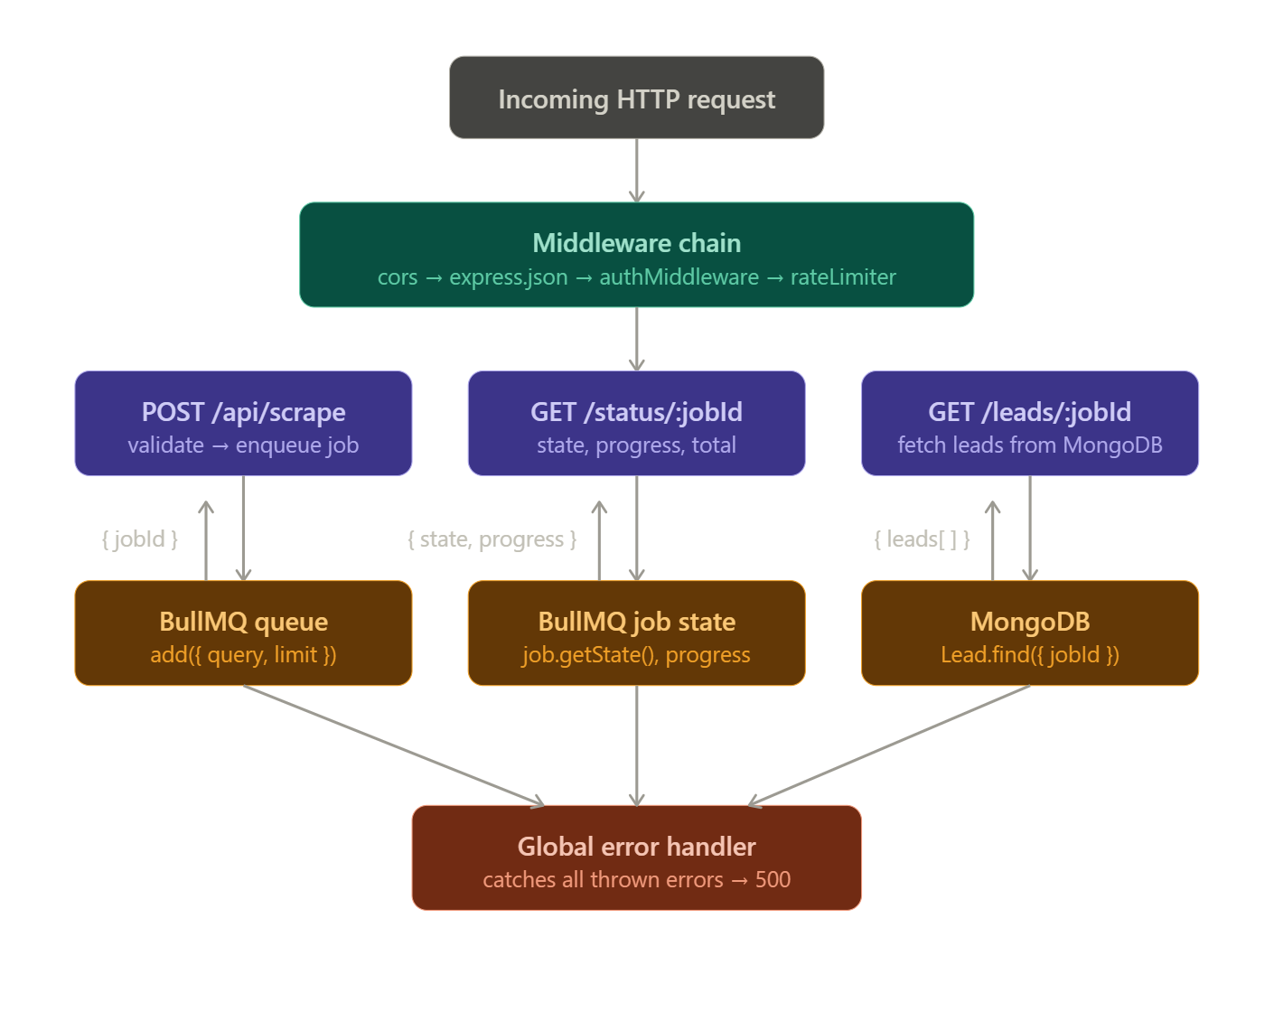
API Layer — Key LLD Decisions:
Every request passes through the middleware chain first — CORS, JSON parsing, auth, and rate limiting — before hitting any route. The API layer never does scraping itself. POST /scrape just validates the input, enqueues a BullMQ job, and immediately returns a jobId. The heavy work is fully delegated to the queue layer. A global error handler catches anything that goes wrong so you never crash the server.

Layer 3 — Queue Layer
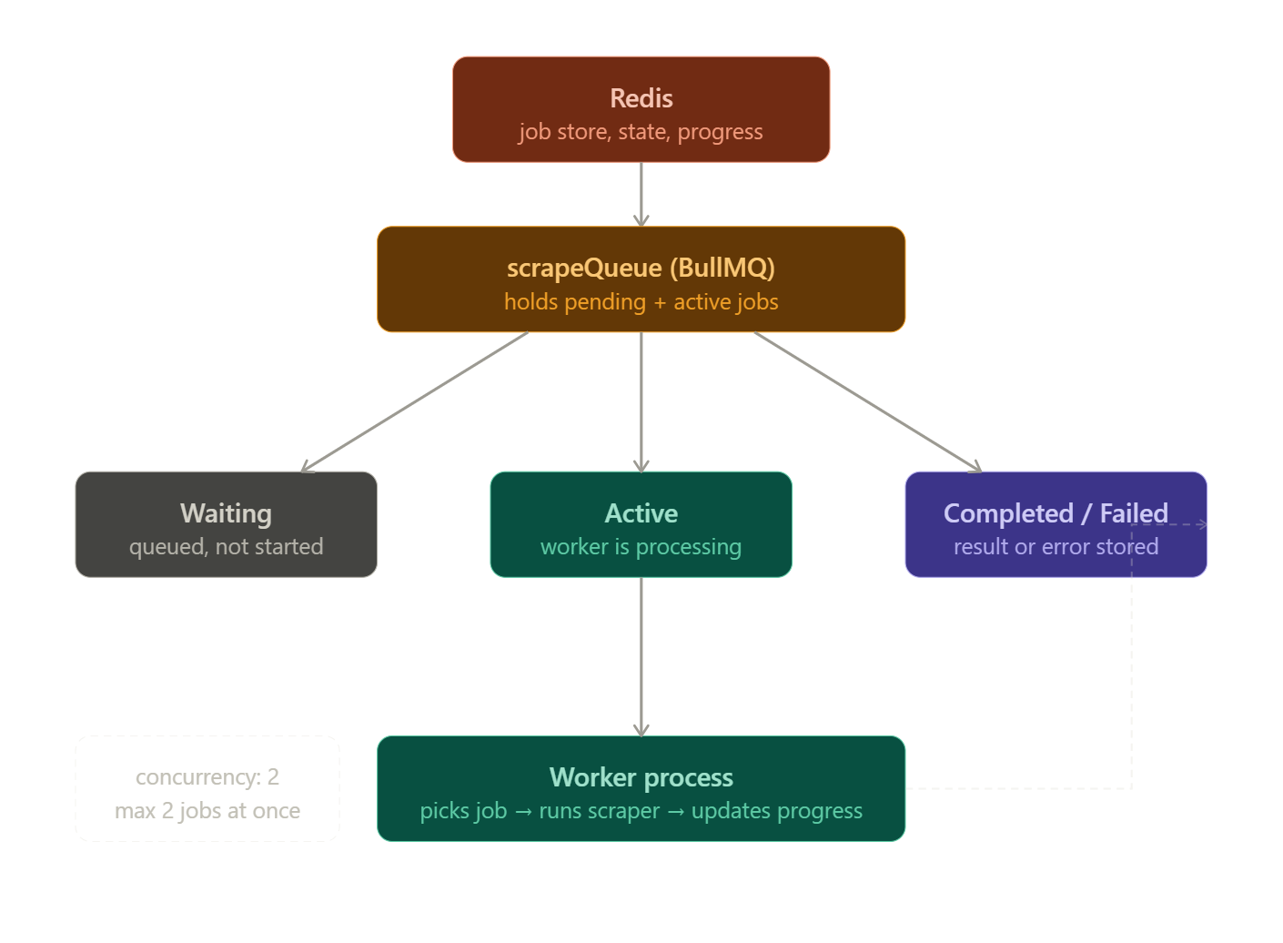

Queue Layer — Key LLD Decisions:
Redis is the actual storage behind BullMQ — every job's state, progress, and result lives in Redis. The worker is a separate process from Express, so a crash in the scraper never takes down the API server. Concurrency is set to 2 meaning a maximum of 2 scraping jobs run simultaneously — this prevents overwhelming Puppeteer with too many browser instances at once. Every time a lead is scraped, the worker calls job.updateProgress() which React picks up via polling.

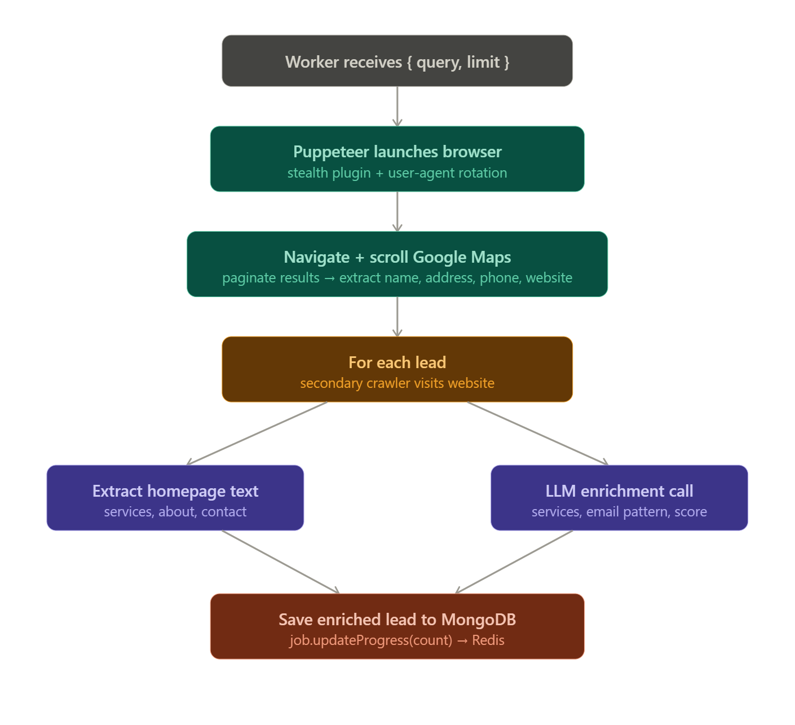
Layer 4 — Scraping + Enrichment Layer

Scraping + Enrichment Layer — Key LLD Decisions:
There are two crawls per lead — the first hits Google Maps for basic data, the second visits the actual business website for deeper content. The LLM only sees homepage text, not raw HTML — you strip the HTML tags before sending to save tokens and reduce noise. After every single lead is saved, job.updateProgress() is called so the frontend progress bar stays in sync. The browser is closed after all leads are done to free memory.

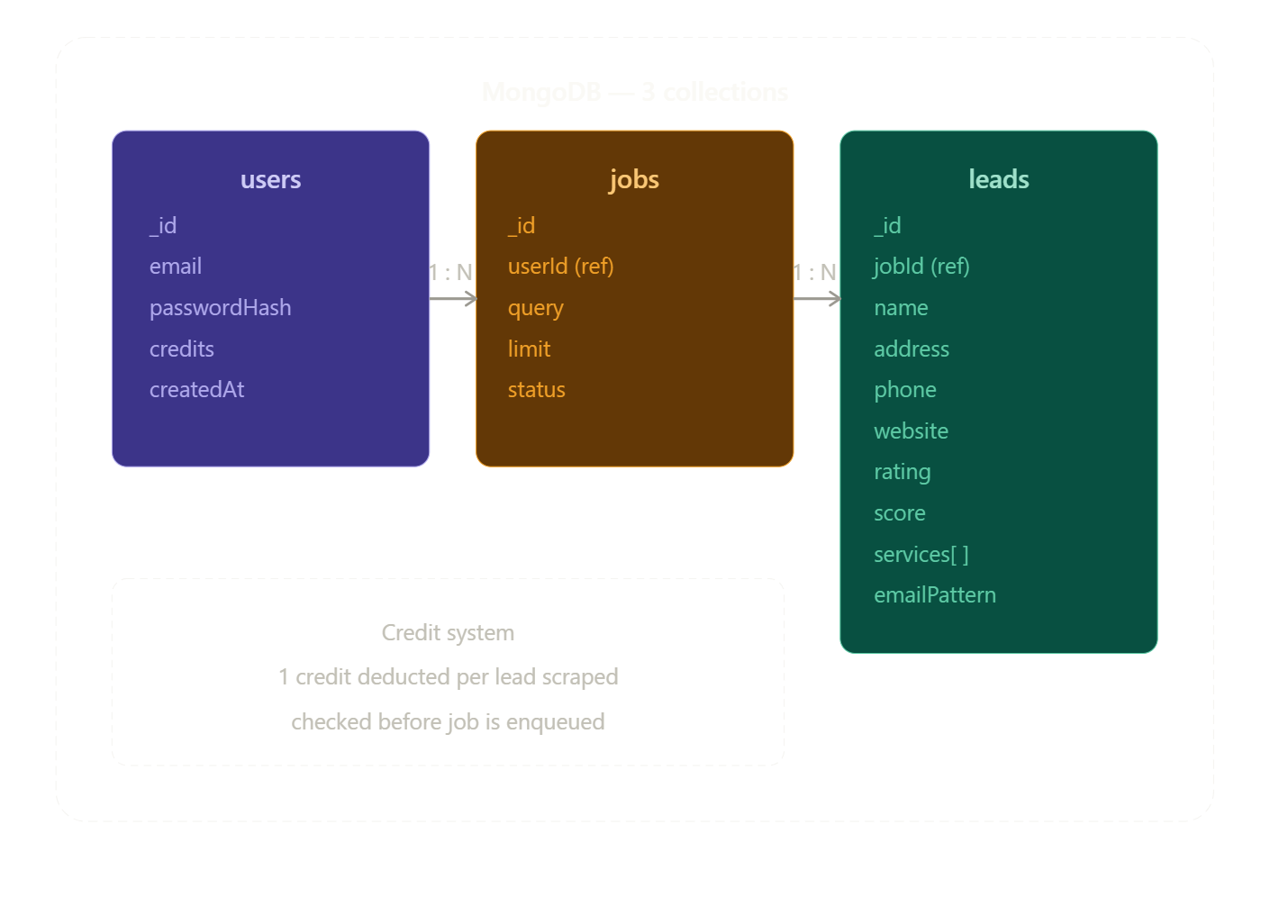
Layer 5 — Data Layer

Data Layer — Key LLD Decisions:
Three collections, clean relationships. One user has many jobs, one job has many leads. The jobId on every lead is how GET /leads/:jobId fetches all leads for a completed job in one query. Credits are stored on the user document and checked before a job is even enqueued — if the user doesn't have enough credits, the job is rejected at the API layer before any scraping begins.

Backend LLD
server/
│
├── src/
│ │
│ ├── config/
│ │ ├── db.js # MongoDB connection (mongoose.connect)
│ │ └── redis.js # Redis connection for BullMQ
│ │
│ ├── middleware/
│ │ ├── authMiddleware.js # verify JWT → attach req.user
│ │ ├── rateLimiter.js # max requests per user per window
│ │ └── errorHandler.js # global error catcher → JSON response
│ │
│ ├── modules/ # one folder per feature module
│ │ │
│ │ ├── auth/
│ │ │ ├── auth.routes.js # POST /auth/register, /auth/login
│ │ │ ├── auth.controller.js # register + login logic
│ │ │ ├── auth.service.js # hash password, sign JWT
│ │ │ └── auth.validator.js # validate email + password format
│ │ │
│ │ ├── scrape/
│ │ │ ├── scrape.routes.js # POST /scrape, GET /status, GET /leads
│ │ │ ├── scrape.controller.js # validate → check credits → enqueue
│ │ │ └── scrape.service.js # interact with queue + lead fetch
│ │ │
│ │ ├── enrichment/
│ │ │ ├── llmClient.js # Gemini / Groq API wrapper
│ │ │ └── enrichLead.js # text → structured lead via LLM
│ │ │
│ │ ├── history/
│ │ │ ├── history.routes.js # GET /history, DELETE /history/:jobId
│ │ │ ├── history.controller.js # fetch + delete job history
│ │ │ └── history.service.js # query Job model by userId
│ │ │
│ │ ├── analytics/
│ │ │ ├── analytics.routes.js # GET /analytics/summary
│ │ │ ├── analytics.controller.js
│ │ │ └── analytics.service.js # aggregation queries on Lead + Job
│ │ │
│ │ └── credits/
│ │ ├── credits.routes.js # GET /credits/balance, GET /credits/usage
│ │ ├── credits.controller.js
│ │ └── credits.service.js # check + deduct + fetch usage history
│ │
│ ├── models/ # Mongoose schemas
│ │ ├── User.js
│ │ ├── Job.js
│ │ └── Lead.js
│ │
│ ├── queue/
│ │ ├── scrapeQueue.js # BullMQ Queue definition
│ │ └── scrapeWorker.js # BullMQ Worker + processor function
│ │
│ ├── scraper/
│ │ ├── browserManager.js # Puppeteer launch + close
│ │ ├── mapsScraper.js # Google Maps scraping logic
│ │ └── websiteCrawler.js # secondary website crawler
│ │
│ └── utils/
│ ├── textCleaner.js # strip HTML → plain text
│ ├── creditManager.js # atomic credit check + deduct
│ ├── cacheManager.js # query cache check + store
│ └── ApiError.js # custom error class
│
├── server.js # starts Express API process
├── worker.js # starts BullMQ worker process
├── .env
├── .env.example
├── Dockerfile
├── docker-compose.yml
└── package.json

Layer 1 — API Layer
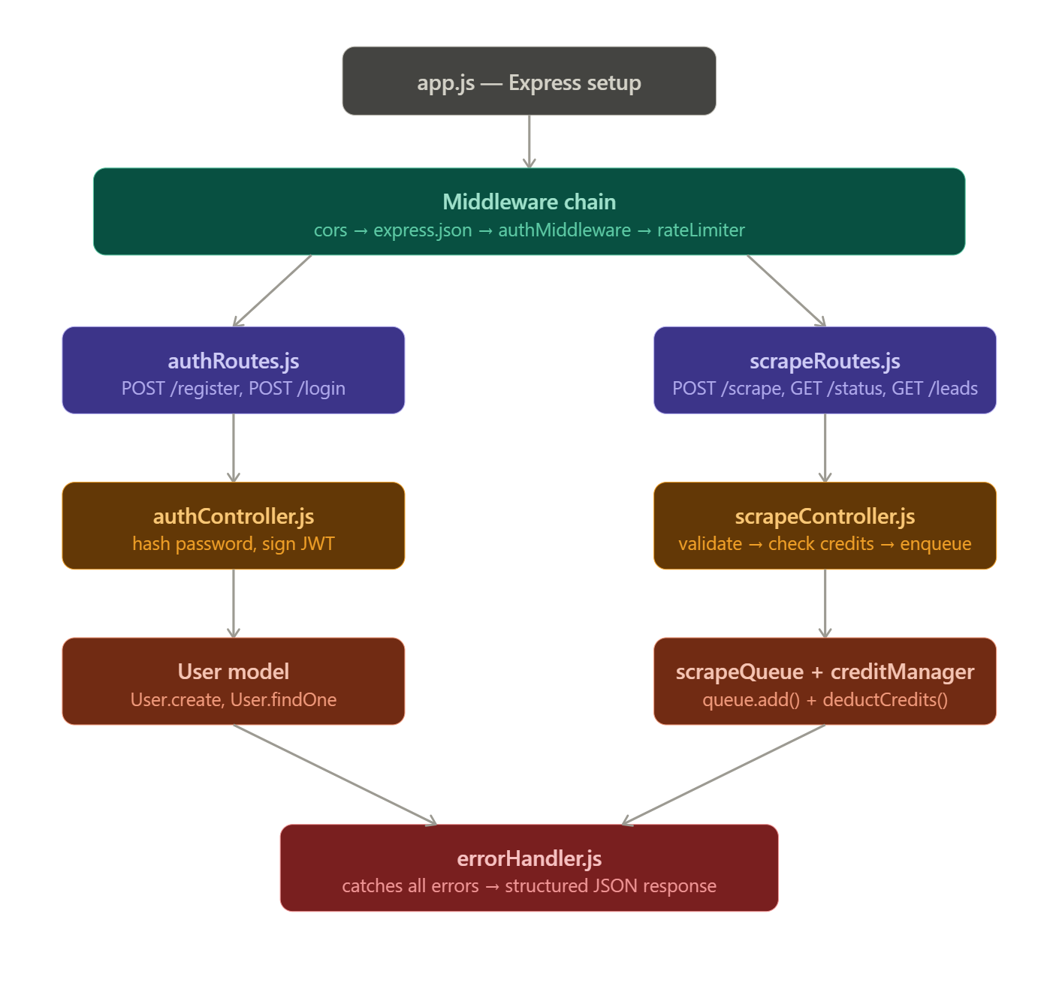

Layer 2 — Queue Layer
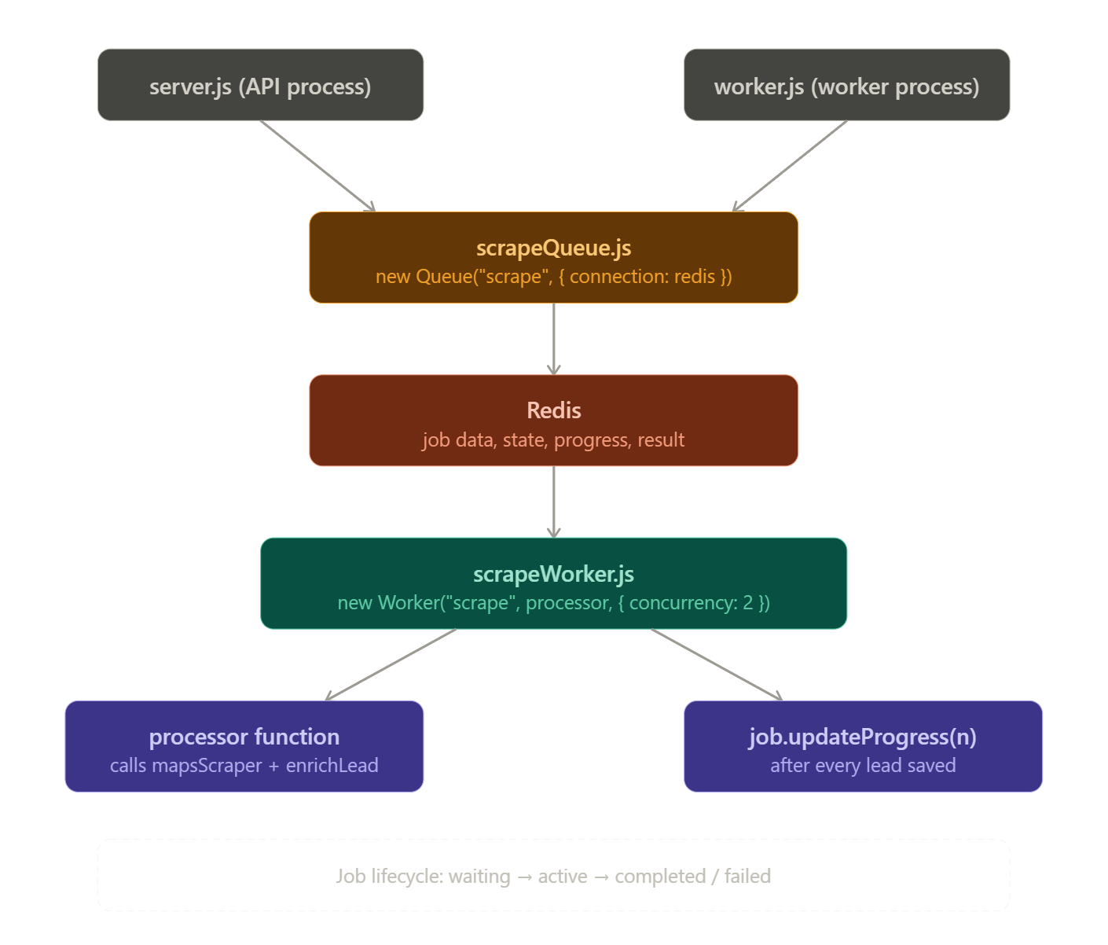

Layer 3 — Scraping Layer
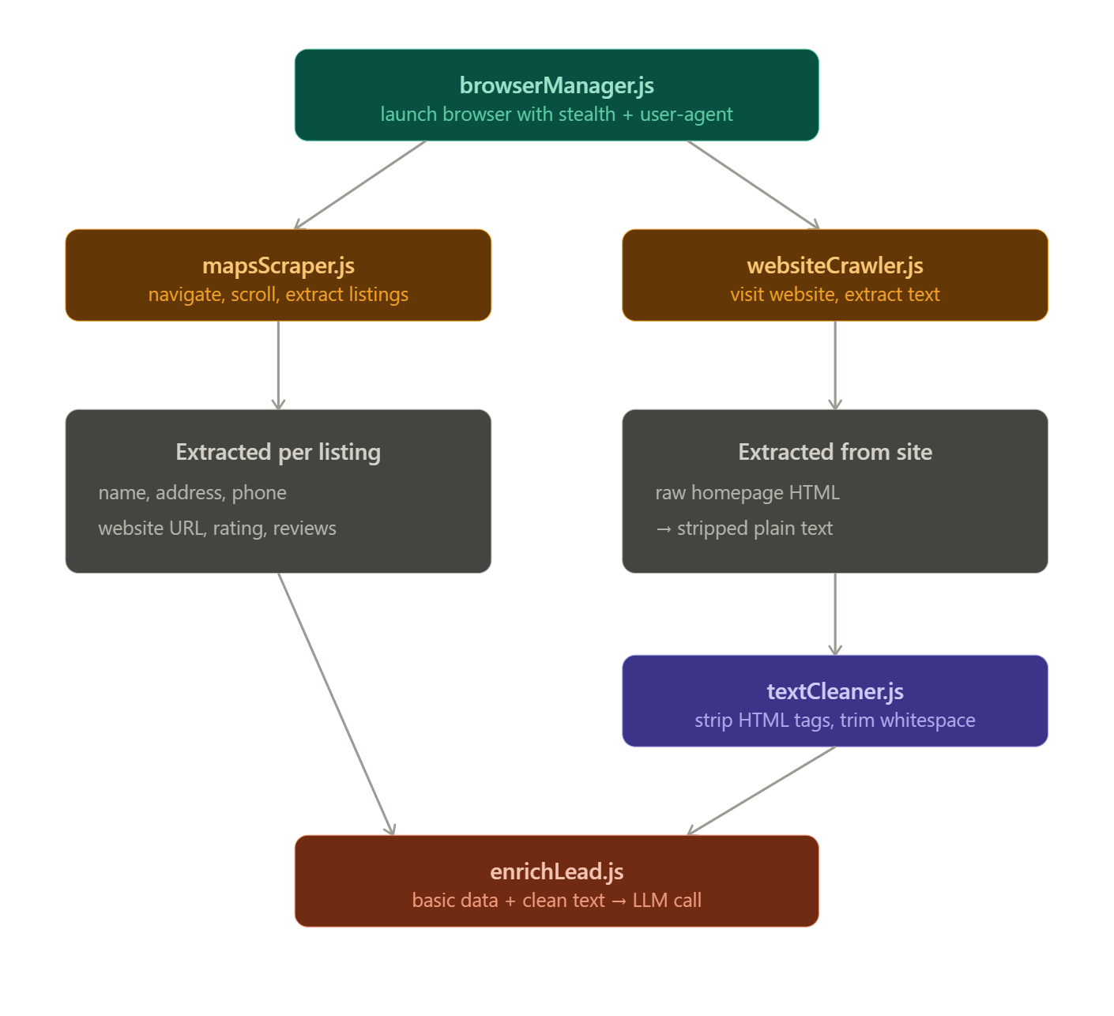

Layer 4 — AI Enrichment Layer
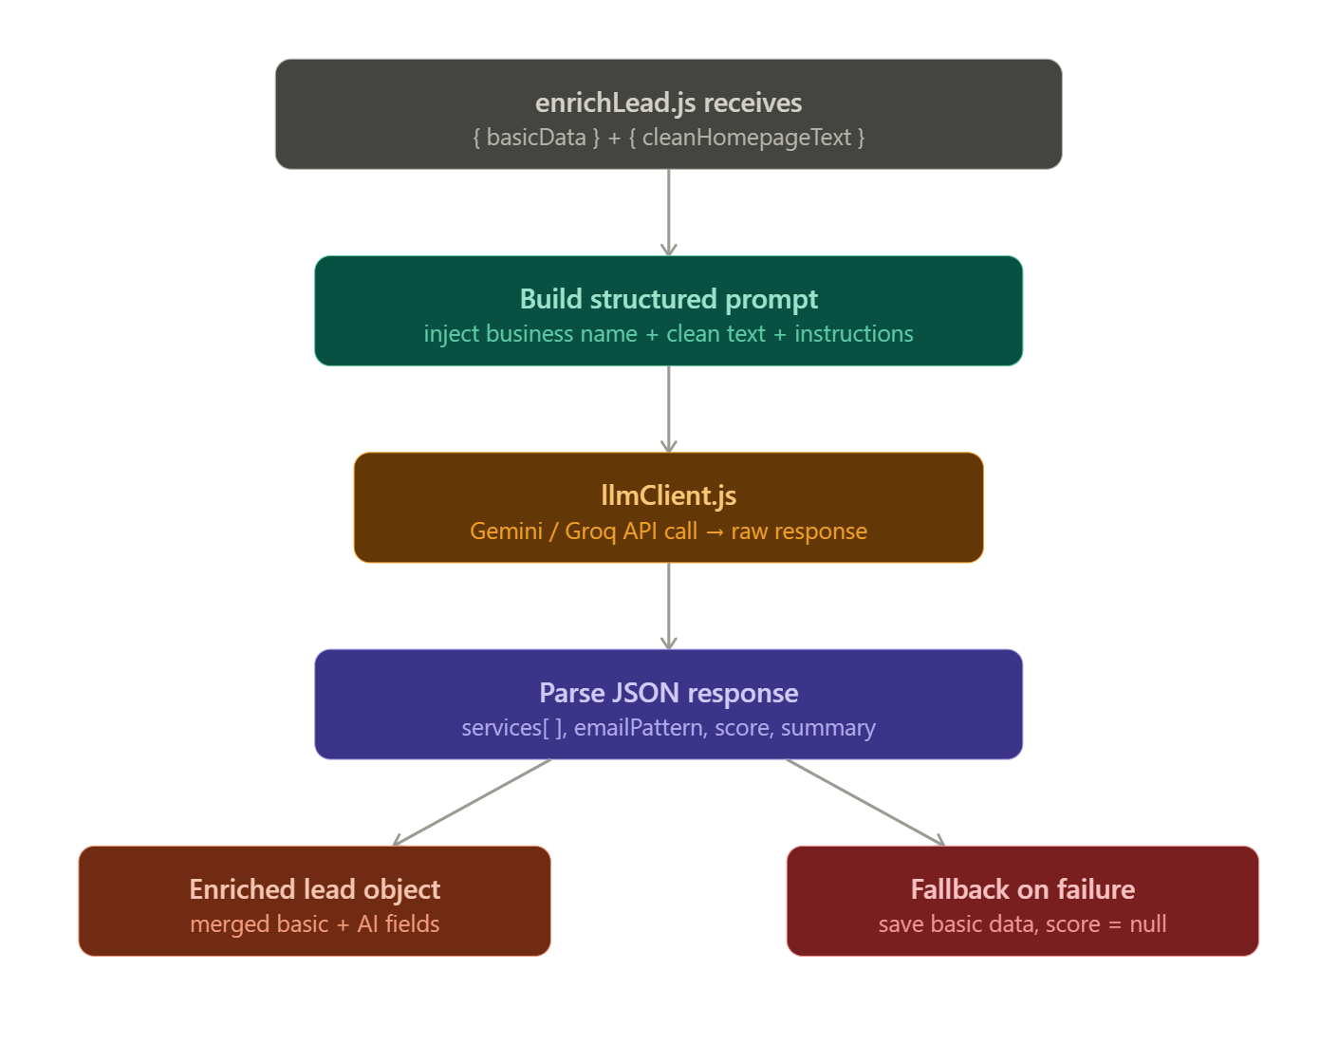

Layer 5 — Data Layer
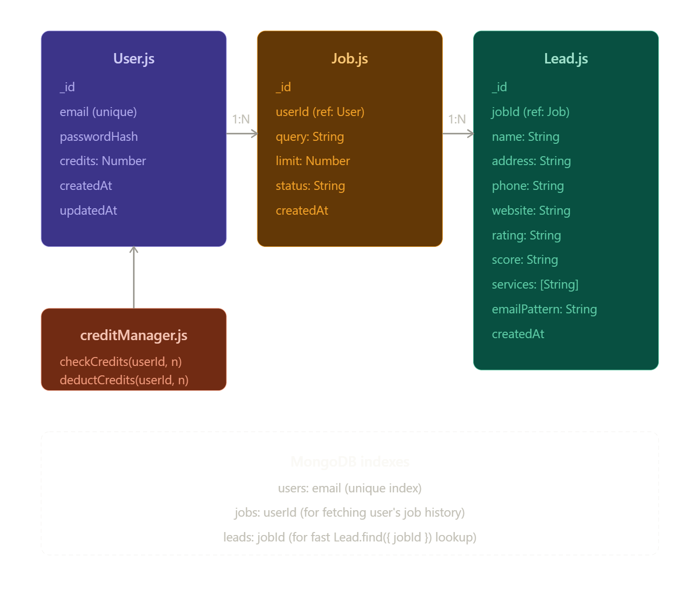

API never scrapes — it only enqueues
Worker never handles HTTP — it only processes jobs
LLM only sees clean text — never raw HTML
Credits checked before job starts — never after
Indexes on every foreign key field

Auth
POST /api/auth/register
POST /api/auth/login

Scrape
POST /api/scrape → enqueue job, returns jobId
GET /api/scrape/status/:jobId → job state + progress
GET /api/scrape/leads/:jobId → final enriched leads

History
GET /api/history → all past jobs for user
DELETE /api/history/:jobId → delete a job + its leads

Analytics
GET /api/analytics/summary → score distribution, trends

Credits
GET /api/credits/balance → current credit count
GET /api/credits/usage → credit usage history

# server/.env
PORT=5000
MONGODB_URI=mongodb+srv://...
REDIS_URL=redis://localhost:6379
JWT_SECRET=your_secret_here
JWT_EXPIRES_IN=7d
GEMINI_API_KEY=...
GROQ_API_KEY=...
CLIENT_URL=http://localhost:5173

client/
├── public/
│ └── index.html
│
├── src/
│ │
│ ├── api/ # all axios calls — one file per module
│ │ ├── authApi.js # register, login, logout
│ │ ├── scrapeApi.js # start scrape, get status, get leads
│ │ ├── historyApi.js # fetch past jobs, delete job
│ │ ├── analyticsApi.js # fetch analytics data
│ │ └── creditApi.js # fetch credit balance, usage history
│ │
│ ├── components/ # reusable UI components
│ │ │
│ │ ├── SearchBar/
│ │ │ ├── SearchBar.jsx
│ │ │ └── SearchBar.css
│ │ │
│ │ ├── ProgressBar/
│ │ │ ├── ProgressBar.jsx
│ │ │ └── ProgressBar.css
│ │ │
│ │ ├── LeadsTable/
│ │ │ ├── LeadsTable.jsx
│ │ │ └── LeadsTable.css
│ │ │
│ │ ├── LeadCard/
│ │ │ ├── LeadCard.jsx
│ │ │ └── LeadCard.css
│ │ │
│ │ ├── ExportButton/
│ │ │ └── ExportButton.jsx
│ │ │
│ │ ├── ScoreBadge/ # High / Medium / Low badge
│ │ │ └── ScoreBadge.jsx
│ │ │
│ │ ├── CreditBadge/ # shows current credit balance
│ │ │ └── CreditBadge.jsx
│ │ │
│ │ ├── Navbar/
│ │ │ ├── Navbar.jsx
│ │ │ └── Navbar.css
│ │ │
│ │ └── ProtectedRoute/ # redirects to login if not authed
│ │ └── ProtectedRoute.jsx
│ │
│ ├── pages/ # one page per route
│ │ ├── LoginPage/
│ │ │ ├── LoginPage.jsx
│ │ │ └── LoginPage.css
│ │ │
│ │ ├── RegisterPage/
│ │ │ ├── RegisterPage.jsx
│ │ │ └── RegisterPage.css
│ │ │
│ │ ├── HomePage/ # search entry point
│ │ │ ├── HomePage.jsx
│ │ │ └── HomePage.css
│ │ │
│ │ ├── ResultsPage/ # progress bar + leads table
│ │ │ ├── ResultsPage.jsx
│ │ │ └── ResultsPage.css
│ │ │
│ │ ├── HistoryPage/ # past scrape jobs
│ │ │ ├── HistoryPage.jsx
│ │ │ └── HistoryPage.css
│ │ │
│ │ └── AnalyticsPage/ # charts + insights
│ │ ├── AnalyticsPage.jsx
│ │ └── AnalyticsPage.css
│ │
│ ├── hooks/ # custom hooks — logic out of components
│ │ ├── useScrape.js # POST scrape + get jobId
│ │ ├── useJobStatus.js # poll status + fetch leads
│ │ ├── useAuth.js # login, register, logout, token
│ │ ├── useHistory.js # fetch + delete past jobs
│ │ ├── useAnalytics.js # fetch analytics data
│ │ └── useCredits.js # fetch credit balance + usage
│ │
│ ├── context/ # global state
│ │ ├── AuthContext.jsx # user, token, isLoggedIn
│ │ └── LeadsContext.jsx # jobId, leads[ ]
│ │
│ ├── utils/ # pure helper functions
│ │ ├── exportCsv.js # leads[ ] → .csv download
│ │ ├── formatDate.js # consistent date formatting
│ │ └── scoreColor.js # High → green, Low → red
│ │
│ ├── constants/
│ │ └── routes.js # all route strings in one place
│ │
│ ├── App.jsx # all routes defined here
│ └── main.jsx # ReactDOM entry point
│
├── .env # VITE_API_URL
├── vite.config.js
└── package.json

